PRESS KIT
A FATHER’S KADDISH*
A story of love, loss, art and ritual

* Kaddish is the Jewish communal mourning prayer

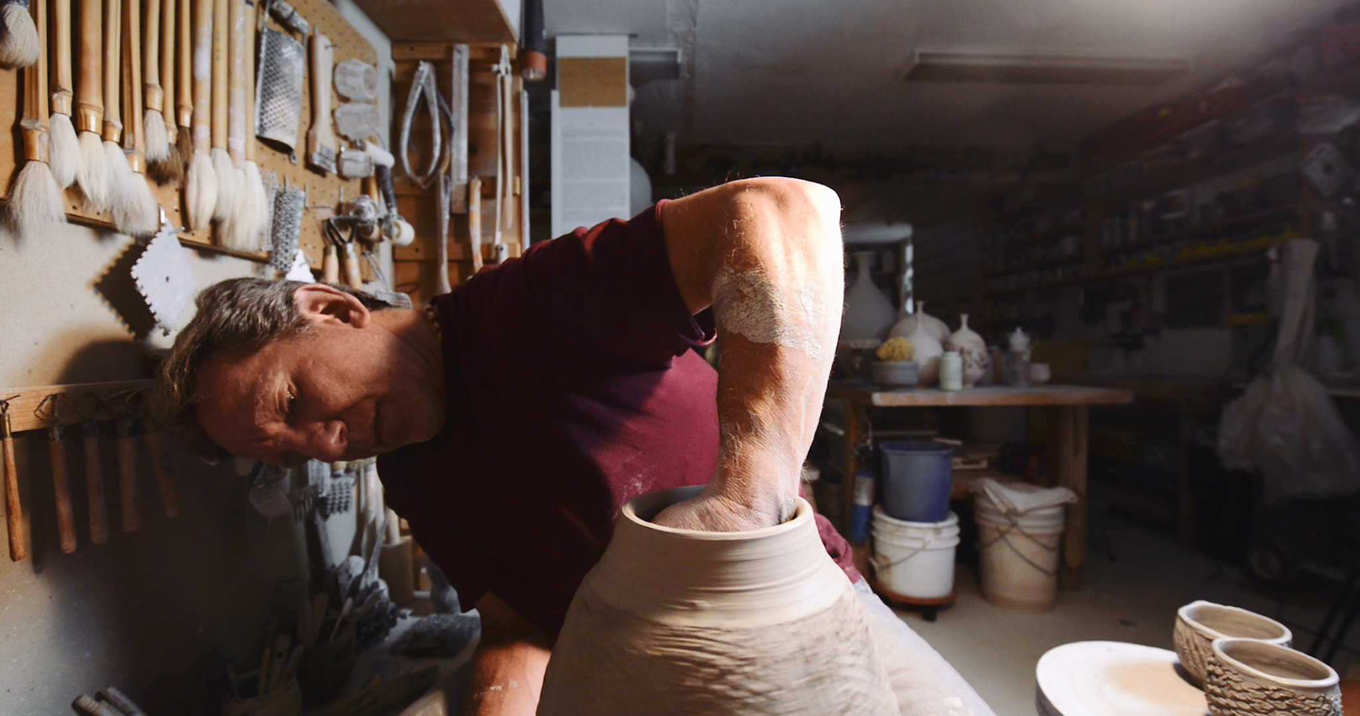

Tagline:

A story of love, loss, art and ritual

Brief Synopsis

A Father’s Kaddish* tells the story of how Steven Branfman used the craft of pottery to help him work through his grief after the death of his 23-year-old son. The film is a potent and moving journey through the universal experience of loss, mourning and rebuilding a life.

Alternative version:

A Father’s Kaddish* tells the powerful and inspiring story of how one artist copes with the death of his 23-year-old son to brain cancer.

Short Synopsis

How does a father go on after the loss of his 23-year-old son from brain cancer? In A Father’s Kaddish, Steven Branfman, a potter and teacher, began his grief process by making one Japanese tea bowl (chawan). He continues by making a new bowl every day for a year after his son Jared’s death. This was his way of saying kaddish (the Jewish mourning prayer). From one man’s poignant story at the intersection of love, art, and ritual comes a universal lesson for all who have experienced loss.

Alternative version:

How does a father go on after the loss of his 23-year-old son from brain cancer? In A Father’s Kaddish, a poignant story of love, loss, art, and ritual, potter Steven Branfman makes one Japanese tea bowl (chawan) every day for a year to honor his child.

Longer Synopsis
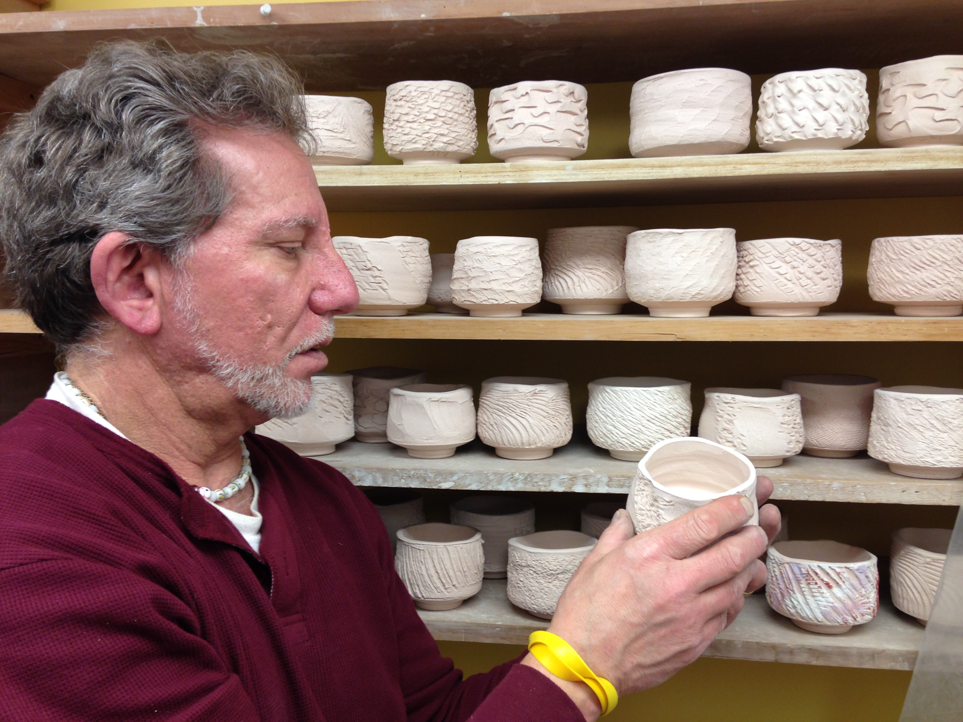
In 2005, Jared Branfman died of brain cancer at the age of 23. A week after his death, his father, Steve Branfman, a potter and teacher, went into his studio, took some clay and made a chawan, a Japanese style tea bowl. Each day for one year, he made one chawan - they were the only pots he made. Steve’s daily chawan made at his wheel was his own personal kaddish, (the traditional Jewish prayer of mourning).

For 9 years, these 365 bowls sat unfinished on shelves in his studio. One day, in the 9th year, he decided to glaze and fire these bowls, bringing them to life with color and sheen.

A Father’s Kaddish is the personal story of a man who created an art form to honor his son and his son’s memory.

This powerful film shows traditional and non-traditional ways for people to grieve. From one man’s poignant story at the intersection of love, art, and ritual comes a universal lesson for all who have experienced loss.

Watch the trailer here

MEET STEVEN BRANFMAN
Steven Branfman received his MAT from Rhode Island School Of Design in 1975 and enjoys an international reputation as a clay artist. In 1977 he founded The Potters Shop & School in Needham MA as his studio, pottery school, gallery, and pottery bookstore. He has been teaching pottery at Thayer Academy in Braintree MA for 42 years. His Raku ware is in the collections of several museums. He is the author of four Pottery and Raku books. He is a popular workshop presenter giving guest demonstrations and lectures of his pottery forming, glazing, and firing techniques all over the world.

MEET THE CREATIVE TEAM

JEN KAPLAN
Director/Producer

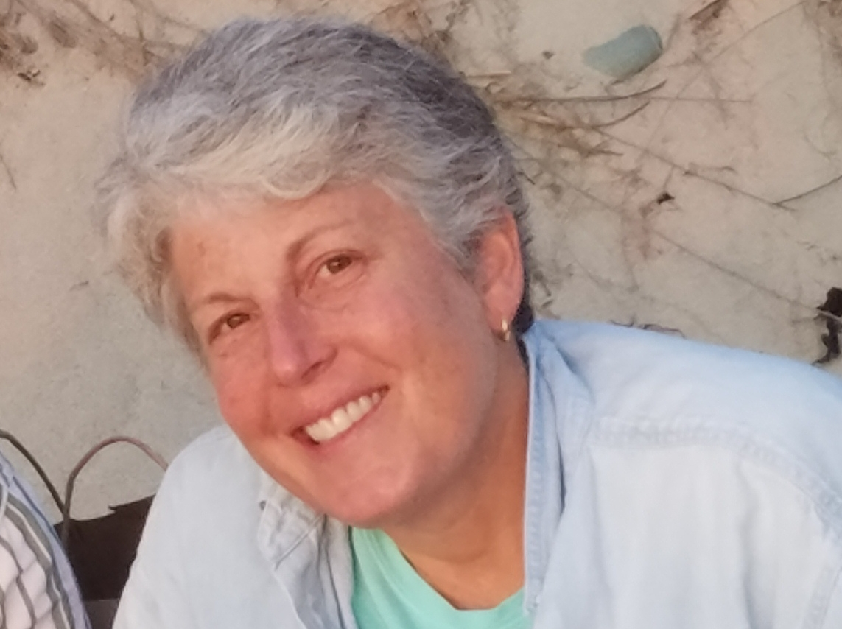
Jen Kaplan’s first love was always the magic of stories – listening to them, learning from them and telling them in a visual way through film, since 2000. Her first film “Mixed Blessings: The Challenges of Raising Children in a Jewish-Christian Family” (www.mixedblessingsfilm.com) was shown in film festivals across the globe and aired on several PBS stations. She worked as a Fundraising Producer at Connecticut Public Television and served as the Associate Director of Filmmakers Collaborative in Boston. She currently serves as a member of the Newton Cultural Commission. Since 2011, she has focused her efforts on producing 5-7 minute films for a variety of clients. A Father’s Kaddish is her most recent film from her company Spencer Films .

RACHEL CLARK
Editor
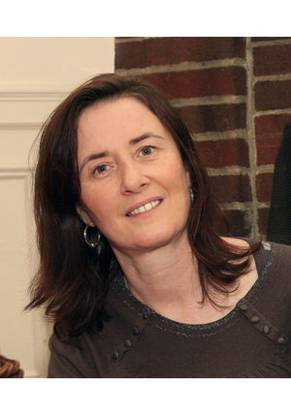

Rachel Clark is a Boston-based documentary video editor. Over the past twenty years of editing, her clients include History Channel, the Discovery Channel, the BBC, Errol Morris, PBS, the National Geographic Channel, and Cinemax. Her work has received multiple Emmy-nominations including the Emmy award winning HBO documentary Have You Seen Andy?; and the documentary Family Affair (OWN), which premiered at Sundance. Recently, a feature length documentary she co-edited, Eat Up, won the “2019 Award for Excellence in Documentary Editing” at Independent Film Festival of Boston.

NIKKI BRAMLEY
Cinematographer
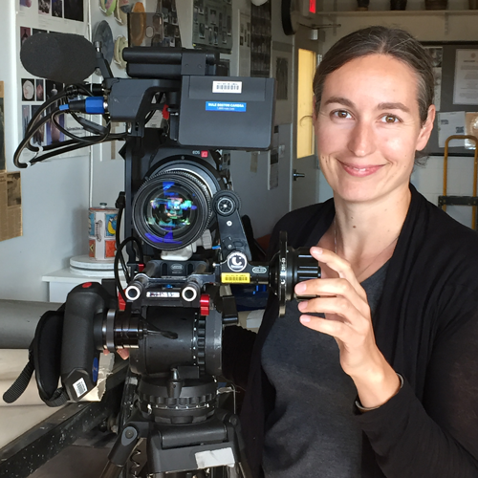
Nikki Bramley is a cinematographer based in Boston. Her work ranges from independent documentaries to high-end commercial projects. Previous camera credits include: Frontline, Runaway Chef: Thailand, Give Me the Banjo (PBS), and various Discovery ID programs, as well as additional camera work for NOVA: The Great Math Mystery, and Finding Your Roots. She was an associate producer on A Life Among Whales (PBS, Discovery), and edited the short documentary Only One Boss (festivals).

SCREENING DETAILS
Run time: 30:56
Audio 5.1 stereo
16:9 ratio
Screening format: DCP

WEBSITES AND SOCIAL MEDIA

www.afatherskaddish.com

https://www.facebook.com/A-Fathers-Kaddish
www.spencerfilms.com

Press Images
Download high-resolution photos here (will do when press kit is all finished)

Press Contact
Jen Kaplan
jen@spencerfilms.com
617-997-6511
221 Linwood Ave.
Newton, MA 02460

